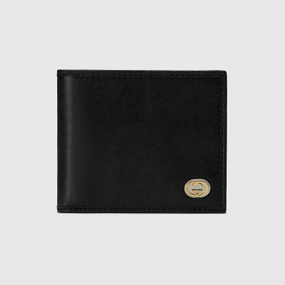

Wallet with Interlocking G

PRODUCT DETAILS

**Recalling retro designs from the 1970s, this wallet is crafted from soft, black leather**

**treated for a vintage effect. The accessory is further enhanced by an Interlocking G**

**detail, presented in a contemporary clash of gold- and silver-toned metals.**

**Eight card slots and two bill compartments**

**• Made in Italy**